C:\Users\The Moody's\AppData\Local\Temp\Temporary Internet Files\Content.IE5\RGW5ACRG\MC900370140[1].wmfReading Homework

Fourth Grade

**Reading Homework Expectation:** In 4th grade, you are required to read for a minimum of 30 minutes, four days a week, from an appropriate level book. Using the book you are reading, you must choose two comprehension questions to answer each week. Questions should be answered with a well-written paragraph, supporting your ideas with evidence from the text.

**Guidelines:**

* Students will choose reading material based on their independent reading level. (See the attachment on how to use Scholastic Book Wizard to select books.)
* Students will select two questions from the attached list to answer each week. The two questions should come from different categories (within, beyond, or about) and should not be repeated in a month.
* Answers should be written in paragraph form and include an introduction, evidence from the text, and a concluding statement.
* The two paragraphs will be submitted each Monday and reviewed by the teacher.
* Students will track their homework completion in their student learning notebooks.

**Comprehension Questions**

**Thinking WITHIN the Text**

* What is this story about? What have you learned so far?
* Can you identify the setting, main characters, events, and problem/solution?
* What was the most important thing the writer had to say?
* What are some new words you found? What do you think they mean?
* What didn’t make sense as you read?

**Thinking BEYOND the Text**

* What pictures or words help your predict what would happen next?
* MCj04061840000[1] How do you think the character is feeling?
* How do you think the author feels about the topic?
* What does this book/part of the story remind you of?
* Has this ever happened to you before?
* Do you know anyone like the main character?
* How is this book similar/different to other books you have read?
* What do you imagine the setting looks like?
* Are there any great descriptive words that let you see a picture in your mind?
* What actors/actresses would play the characters in a movie?

**Thinking ABOUT the Text**

* What did you notice about how the writer told the story?
* What did the writer do to make the story or article more interesting?
* What is the most important idea(s) in the text?
* How did the author create mood in the story?
* How do you feel about the story or topic?
* Would you recommend this book? Why or why not?

Name __________________________________ Date Due ____________________

Reading Homework

|  |  |  |
| --- | --- | --- |
| Date | Title of Book | Minutes & # of Pages Read |
|  |  | _____ minutes and p_____-_____ |
|  |  | _____ minutes and p_____-_____ |
|  |  | _____ minutes and p_____-_____ |
|  |  | _____ minutes and p_____-_____ |

C:\Users\The Moody's\AppData\Local\Temp\Temporary Internet Files\Content.IE5\RGW5ACRG\MC900370140[1].wmf

Parent Signature: ____________________________________________________

Comprehension Question:

___________________________________________________________________________________________________________________________________________________

Response:

________________________________________________________________________________________________________________________________________________________________________________________________________________________________________________________________________________________________________________________________________________________________________________________________________

Comprehension Question:

___________________________________________________________________________________________________________________________________________________

Response:

________________________________________________________________________________________________________________________________________________________________________________________________________________________________________________________________________________________________________________________________________________________________________________________________________

________________________________________________________________________________________________________________________________________________________________________________________________________________________________________________________________________________________________________________________________________________________________________________________________________

**SCHOLASTIC BOOK WIZARD**

Go to Scholastic Book Wizard (**http://www.scholastic.com/bookwizard/**) to search for books that are on your independent reading level.

|  |  |
| --- | --- |
| Date | My Independent Reading Level(s)*  *This level/range is based on what a student can read independently at home. It is NOT their classroom instructional level that is noted on the report card. |
|  |  |
|  |  |
|  |  |
|  |  |

**Ways to Search for a Book:**

**Search for All Books**: Type in the name of any book and it will give you the guided reading level for that book.

**Search for Similar Books**: Does your child want to read a specific book but it seems too difficult or too easy? Put in any title and find similar books that are on your child’s level.

**Search by Reading Level:** Put in your child’s reading level and search through thousands of books by topic, genre or author.

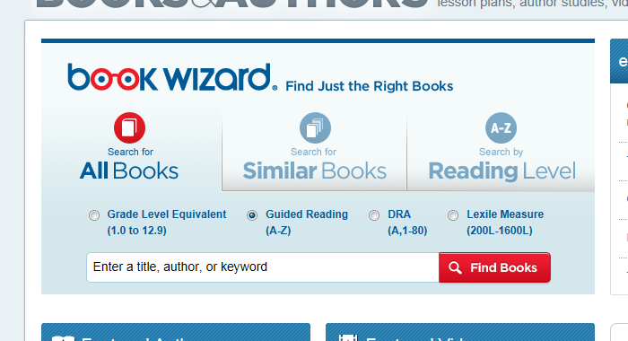**\*Be sure to use Guided Reading**