A Day in the Life of Ho Nee Qua Tow
Ho Nee Qua Tow's day begins as the sun begins to shine in the morning sky. When everyone is up, Ho Nee Qua Tow folds the blankets her family used for sleeping. These blankets were woven from dog hair that was spun into a wool-like fiber. Ho Nee Qua Tow lives in a shelter called a witchott with her husband and son. The village they live in is made up of 20 witchotts.

Making Breakfast

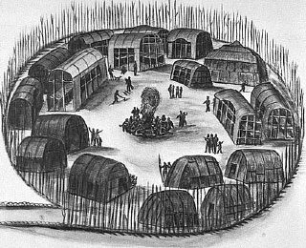
Illustration by Theodore De Bry, ca. 1690
The Yaocomaco witchotts are built in a circle with the doors facing a central area. This area is where much of the village activity takes place. The central area is kept very clean by all of the members of the village. Fences called palisades surround the village. These palisades are built for protection.
Ho Nee Qua Tow begins her day by preparing her family's morning meal. She takes some cornmeal from a covered basket. She prepared the cornmeal yesterday by grinding up some sun-dried, shelled maize (Indian word for corn) with a mortar and pestle. She places the cornmeal in a clay pot. To this, Ho Nee Qua Tow adds some water. This makes a batter, which she makes into cakes. She puts the cakes on hot stones which she removes from the fire that is always kept burning in the witchott.

Picking Berries
While her cakes are cooking on the stones, Ho Nee Qua Tow goes out to the wooded area just beyond the village to pick some wild berries for breakfast. There are many kinds of berries in the woodland - strawberries, mulberries, raspberries, cherries, gooseberries, and grapes. Berries are plentiful at this time of year. The berries will be used for several things. Some of them will be eaten fresh, some put into soups, some will be dried in the sun for eating in the colder months, and some will be used to make color for face and body painting.
Complete Item #4 on your Worksheet.
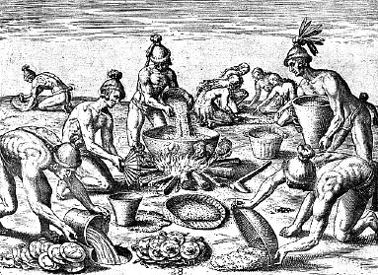
Illustration by Theodore De Bry, ca. 1690
When Ho Nee Qua Tow returns to the witchott with the berries, the corncakes are ready. She will serve her family some smoked turkey meat she has in a basket along with the berries and corncakes. The family eats the food sitting on the floor of the witchott.

Making Pottery
After they have finished eating, Ho Nee Qua Tow plans to work in her vegetable garden. But she has several things to do before she goes. First, she takes the trays of green corn outside to dry in the sun. These will stay out until the sun sets and then she will bring them back inside. The seeds will be left outside like this until they are completely dried.

Answer question 5 on your worksheet.

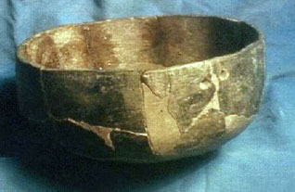  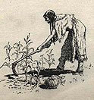 | Now Ho Nee Qua Tow now gets her set of deer antlers that she uses for working in the garden. On her way to the plot of ground where she grows vegetables, she stops by her friend's witchott. Her friend is making pottery today. Ho Nee Qua Tow admires the shape and color of the pots her friend is making. Her friend is very skilled. Ho Nee Qua Tow is just learning to make pottery. Her pots are not as beautiful as her friend's, but they work for her family.  Gardening  Once in the garden, Ho Nee Qua Tow weeds in between the rows of tobacco, beans, and corn. It is time for planting pumpkins and squash. These will be planted in mounds at the base of the corn now that it is half grown.  Ho Nee Qua Tow pushes the dirt up into small hills or mounds using a crooked tree branch with a shell on the end. This serves as a garden hoe. Then she uses the deer antlers to make small holes in the mounds. The seeds for the pumpkins and squash go into the holes. The shade from the half grown corn is just enough to protect the young squash and pumpkin seedlings from the sun.

Gathering Oysters
Ho Nee Qua Tow leaves the garden. Since it is too early in the season to gather nuts, such as acorns, walnuts, chestnuts, buckeye, chinquapins, and hickory nuts, she goes to the river to gather a basket full of oysters. She will use the oysters in the soup she plans to make for the evening meal. She hopes to find a turtle to put into the soup, too. Today Ho Nee Qua Tow will only gather enough oysters for the soup. Later in the season, she will gather enough for smoking and drying for use in the winter. But today she only gathers enough for the soup. Answer Item #7 on your Worksheet.

Preparing the Evening Meal
When Ho Nee Qua Tow returns to her witchott, she begins to prepare the evening meal. Tonight she will serve oyster stew. Stews are a favorite food of the Yaocomaco Indians. This stew will contain oysters, maize, and other fresh fruits and vegetables. It will also contain tockawhoughe - the "Indian potato." After everything is in the pot, Ho Nee Qua Tow lets the stew simmer over the fire for awhile.

While she is waiting for the stew to cook, Ho Nee Qua Tow works on the basket she has been weaving. Baskets are very important items for the Indians. They are used for gathering and storing all kinds of foods. This is a task Ho Nee Qua Tow never seems to finish. There will always be a need for more baskets! She sits in front of the witchott with other members of the village while she works.

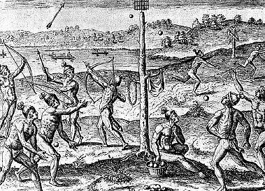  Illustration by Theodore De Bry, ca. 1690 |  |  | After the meal, the family goes to a field where the young men play a game in which they cast a ball at a square target placed on the top of a high tree.
When the sun finally sets and it become dark, it is time for sleeping. The family goes home to its witchott. Ho Nee Qua Tow spreads out the blankets she folded up in the morning on the sleeping platforms. She and her family go to bed - until the sun rises and the pattern of Indian life, in tune with the seasons, begins again

